# **Visualizing Cluster Data using Power BI**

This demo is for visualizing some default data that is available HDInsight Cluster. For doing the HOL, make sure to create a HDInsight cluster. Also you need Power BI desktop tool installed in your machine. Download the tool from below given link and install it.

<https://powerbi.microsoft.com/desktop/>

After installing, login into it and sign in or create an account using your organizational mail ID. In the homepage of Power BI, go to **Get Data** and click on **More** option.

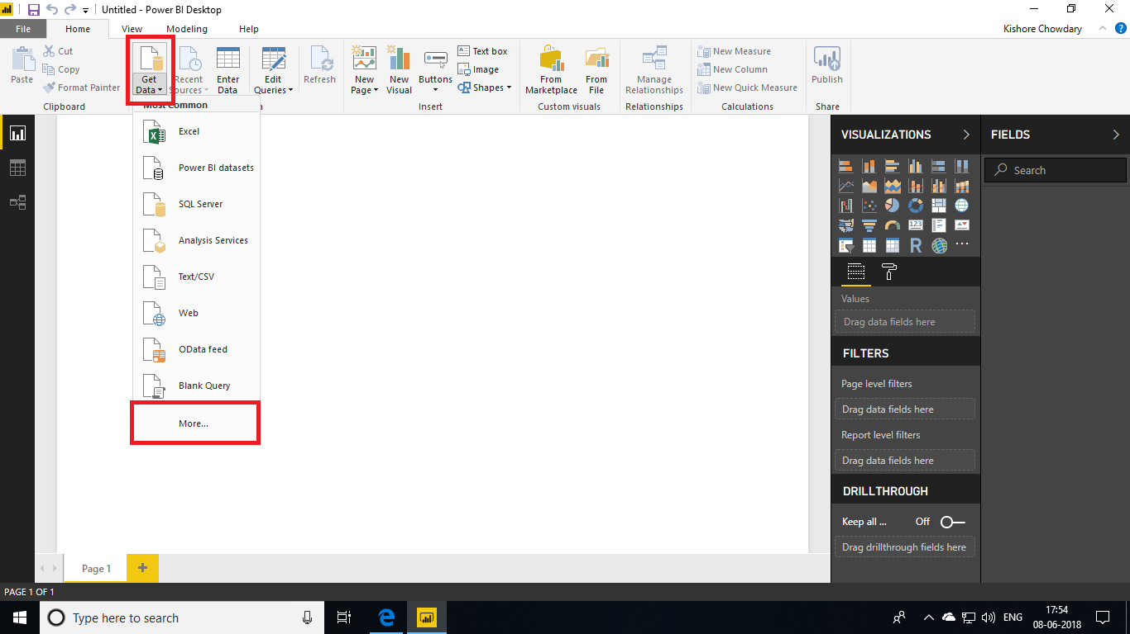

Next to this, select **Azure HDInsight (HDFS)** and click on **Connect**.

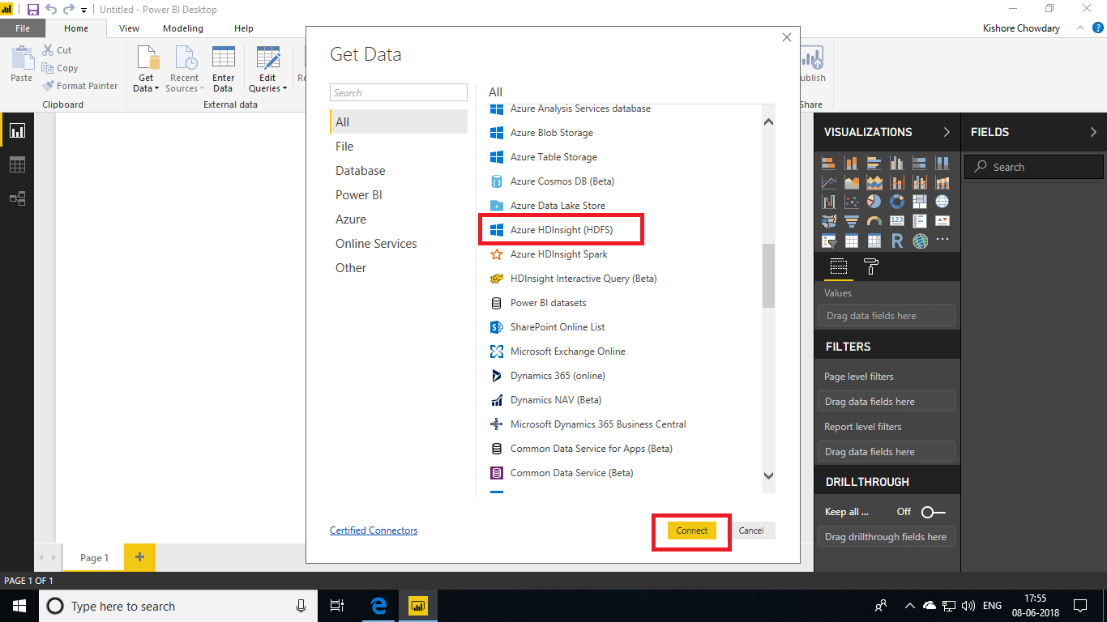

Click on **Continue** when you get the below given message.

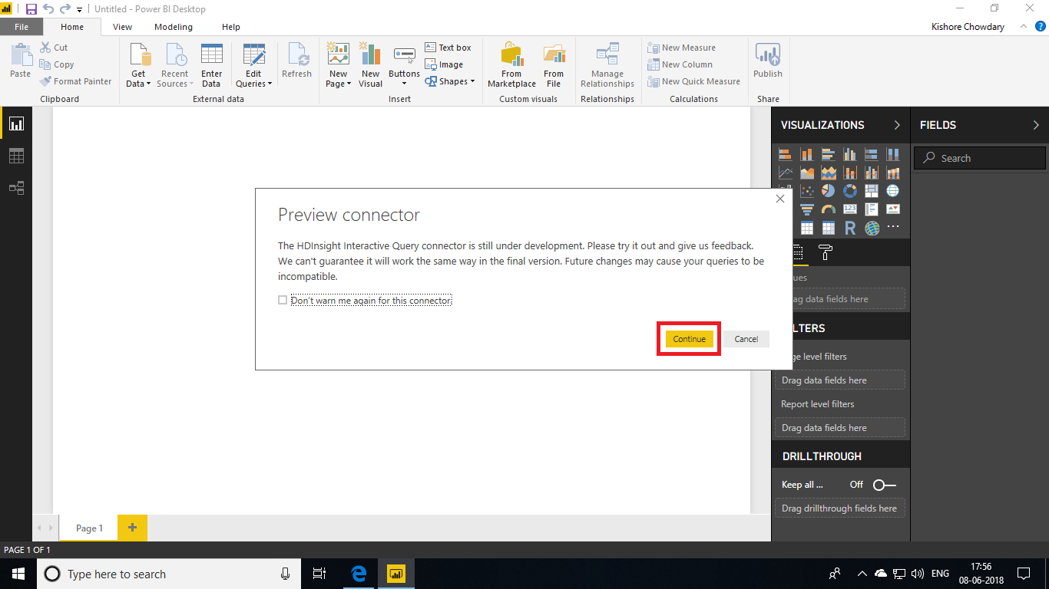

Give the cluster’s DNS and database name as **Default** and choose the connection mode as **DirectQuery** and click on **Ok**.

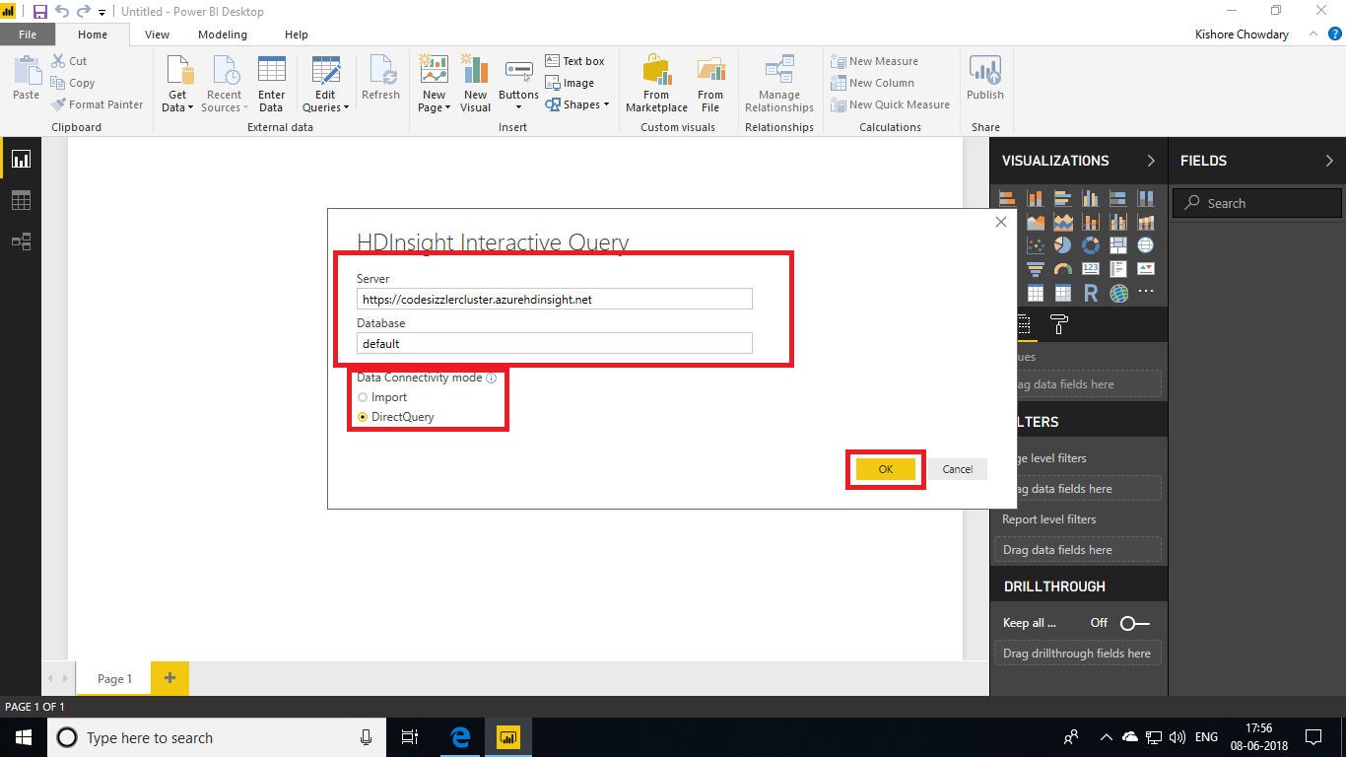

Next you will be asked to enter user name and password of the cluster. Give those data and click on **Connect**.

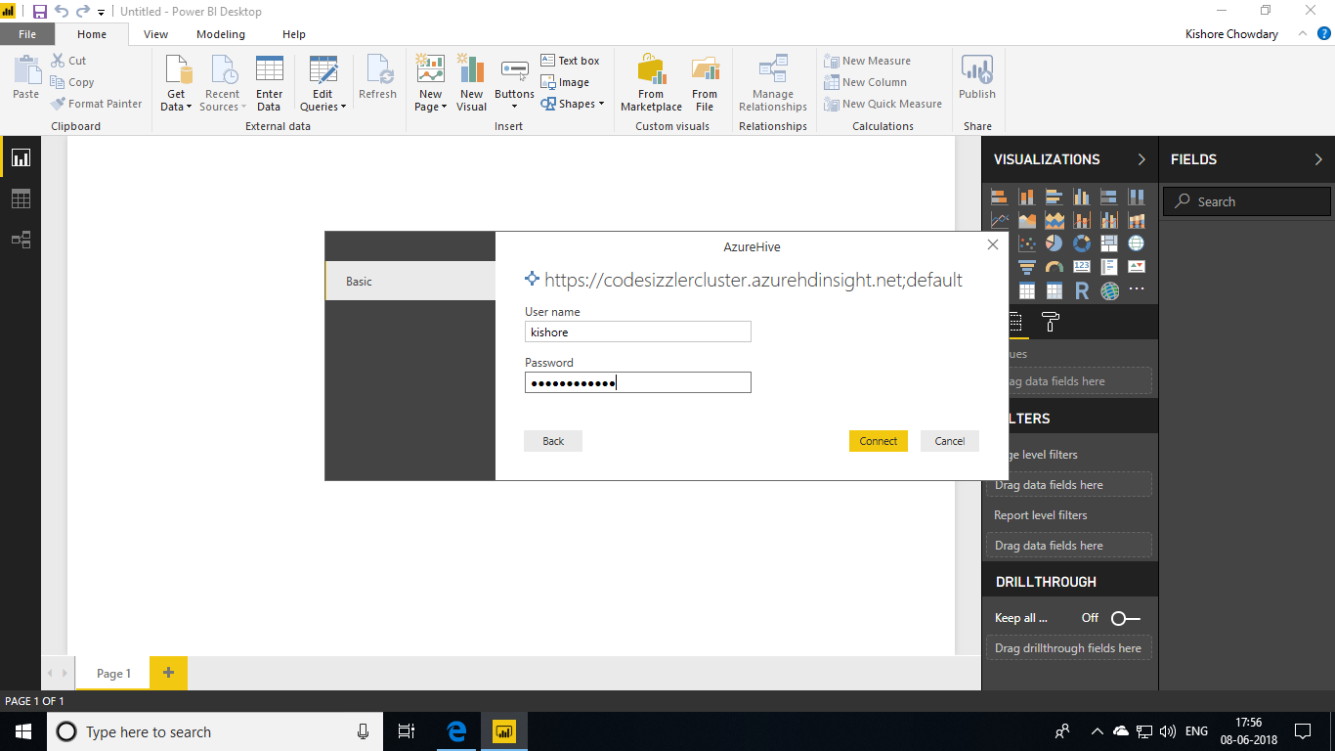

Now choose the **hivesampletable.** The data in the table will be displayed. Click on **Load** button to load data for visualization.

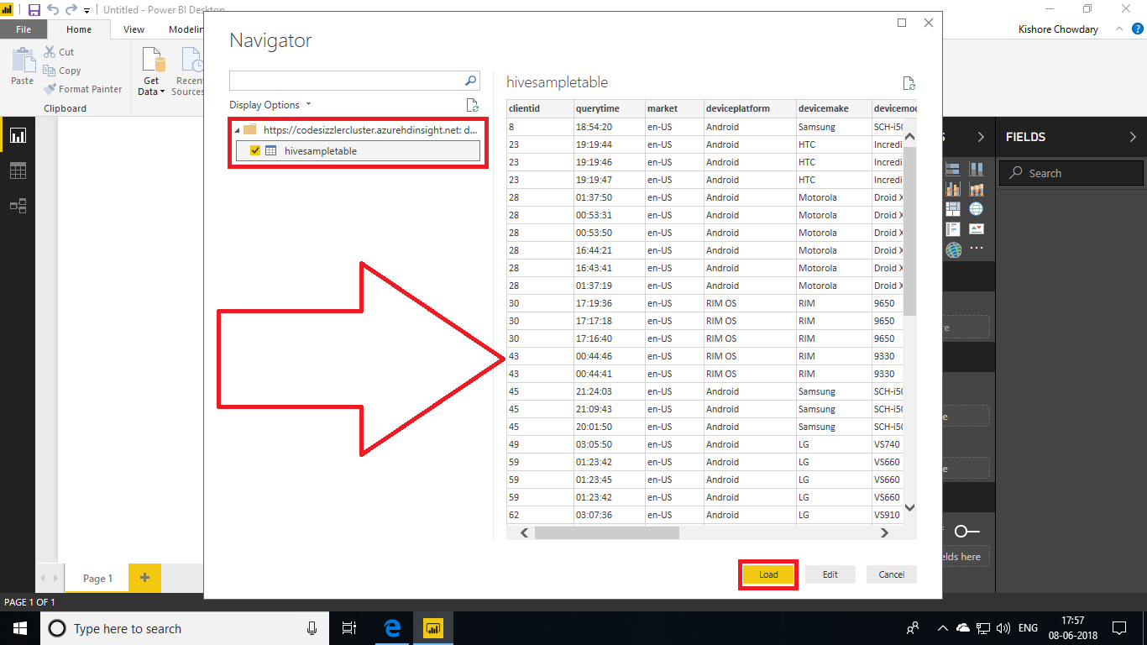

After loading the data, select **Country and Devicemake** from the fields of hive sample table. It will visualize all the data in graph with differentiations.

